**Day 2 -AWS (S3 &EFS)**

* S3 comes under **storage service**
* S3 to store any kind of data. So, you can store any unstructured data or structured data. You can store your files, videos, images, anything can be stored inside your S3 bucket.
* inside s3 you will be creating **buckets.** it's a kind of a folder to organize your data.
* **you can create 100 buckets. So 100 buckets is a limitation for every account. Unlimited data can be stored inside your backet.**
* To properly organize your data, we do it with the help of buckets.
* So, you can connect your S3 buckets through the Internet to access your data.
* **S3 storage can be accessed. The data that you put inside your S3 bucket can be accessed or retrieved through the Internet.**
* ***“the data are stored in the form of objects”.so S3 called as “object based storage”.***

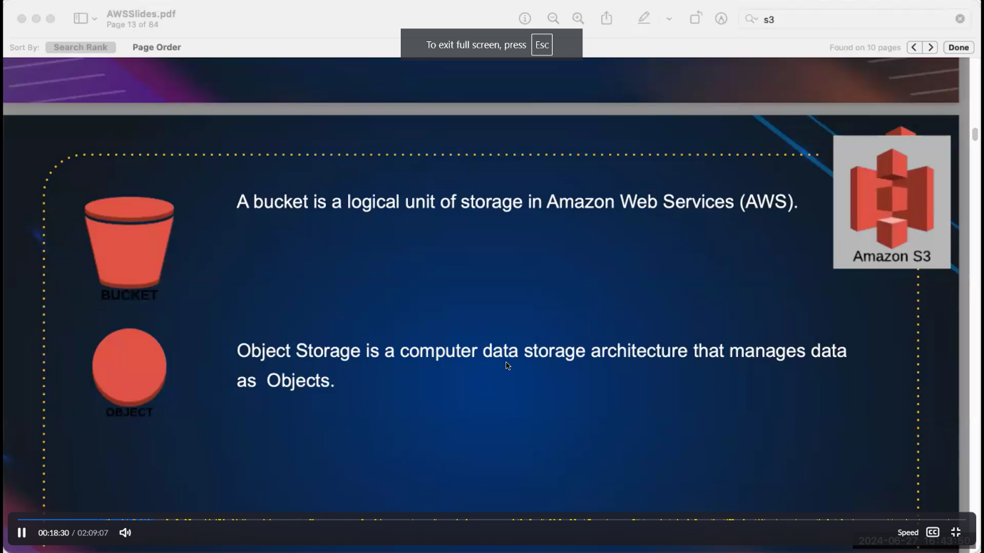

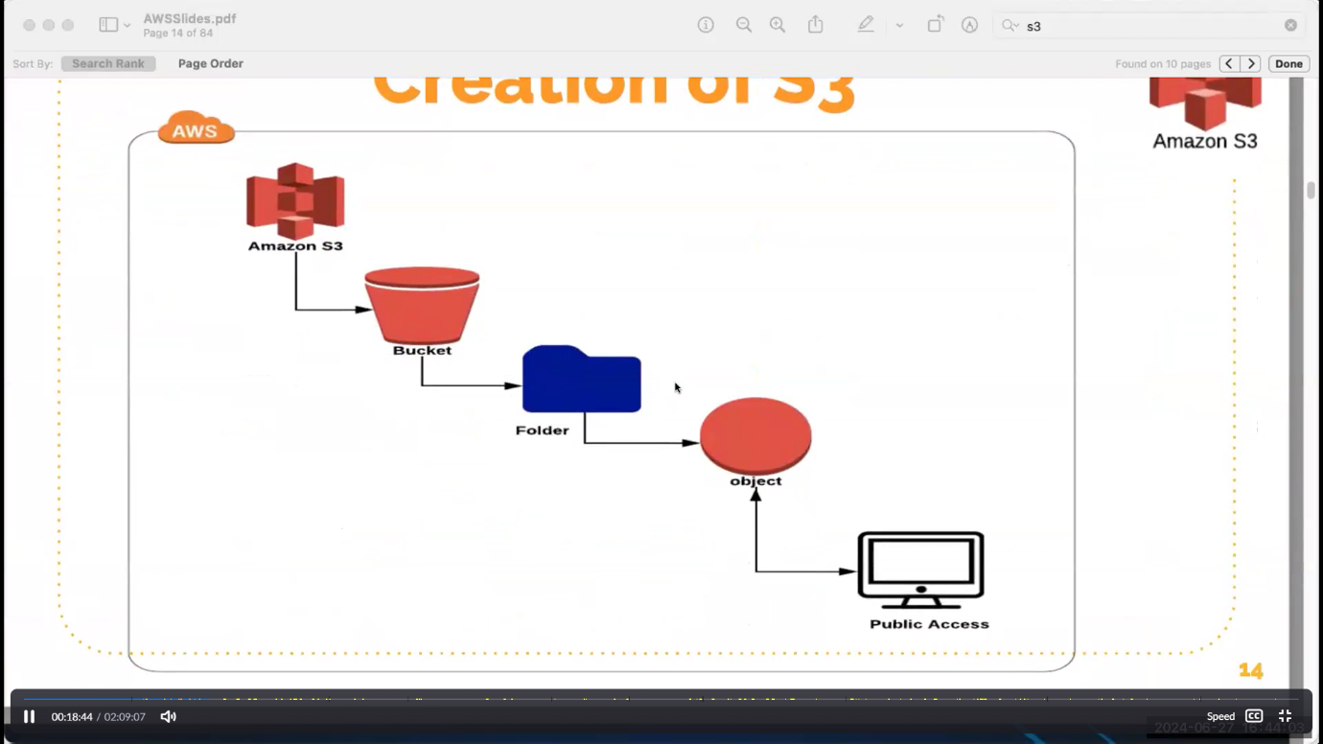

We can share bucket to diff ec2

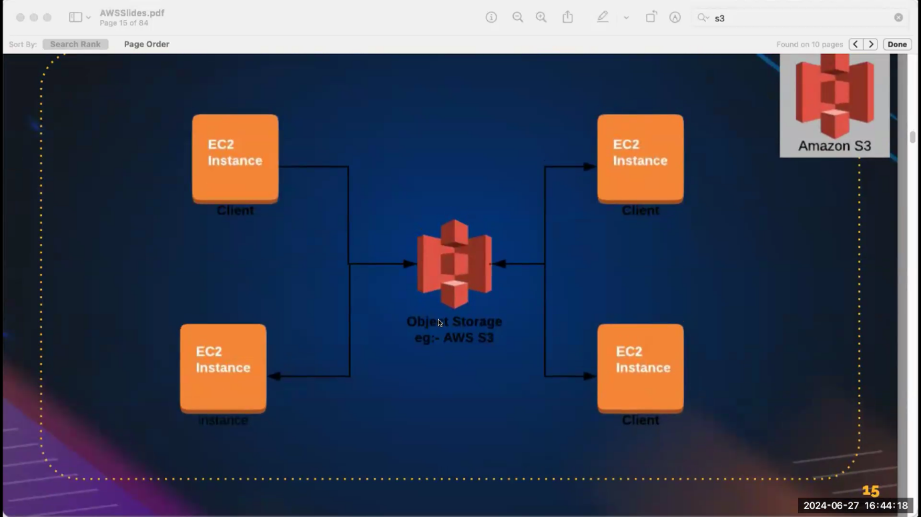

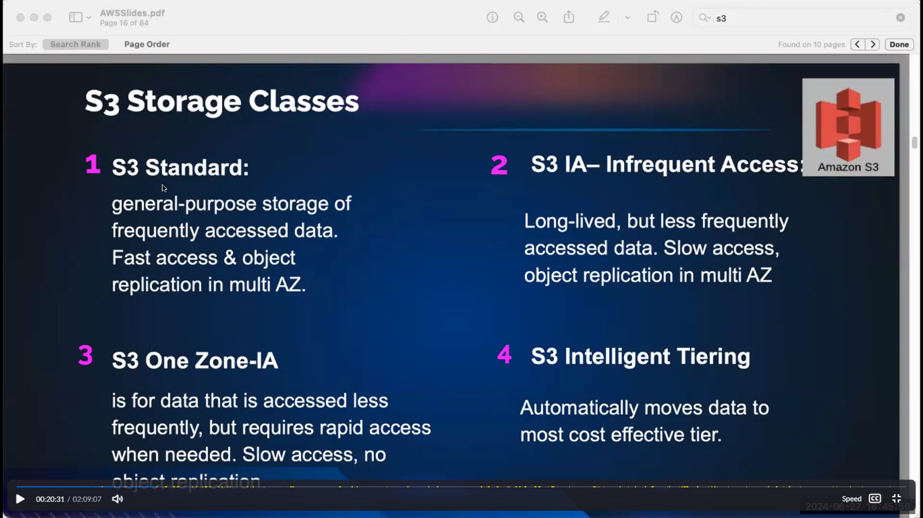

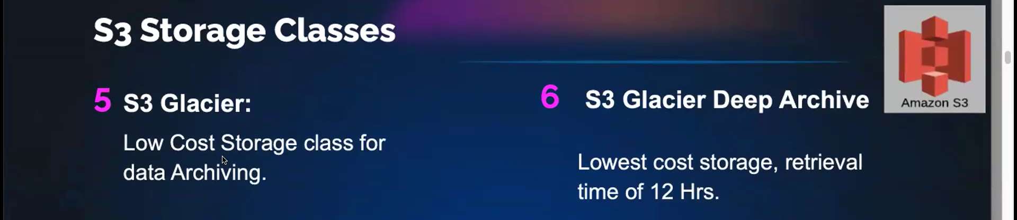

Pricing differs for every classes.

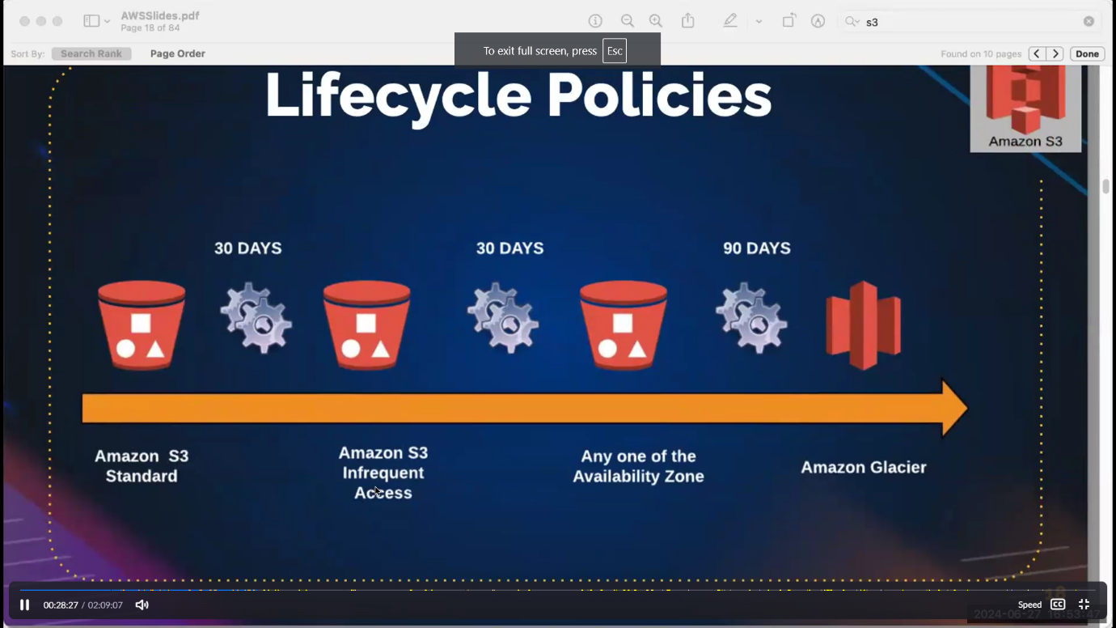

* Data can not use more than 30 days put it in S3 infrequent access.
* Data can not use more than 90 days put it in S3 amazon glacier.

<https://us-east-1.console.aws.amazon.com/s3/get-started?region=us-east-1>

**how to create a bucket:**

Bucket name is unique like gmail. because your bucket name comes under the global namespace

* **So I'm just giving Acl enabled, which means I can access the bucket out of my aws account also. But this is not recommended.**
* **Always in order to keep your data, we have to maintain the data's integrity to secure your data. We don't go with the we don't enable Acl Acl means you can share your data among multiple aws account. So if I want to access my data through the Internet.**
* **you should also block all the in disable block all public access, just disable**
* **if you don't want to access your data, you have to select Acl disabled**
* by default. For the data security, everything will be enabled so that your data isn't shared is not going out. From your aws account
* inside bucket we can store data or run static website

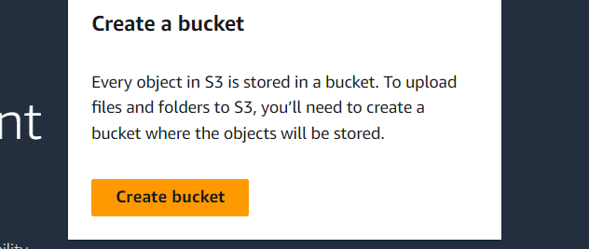

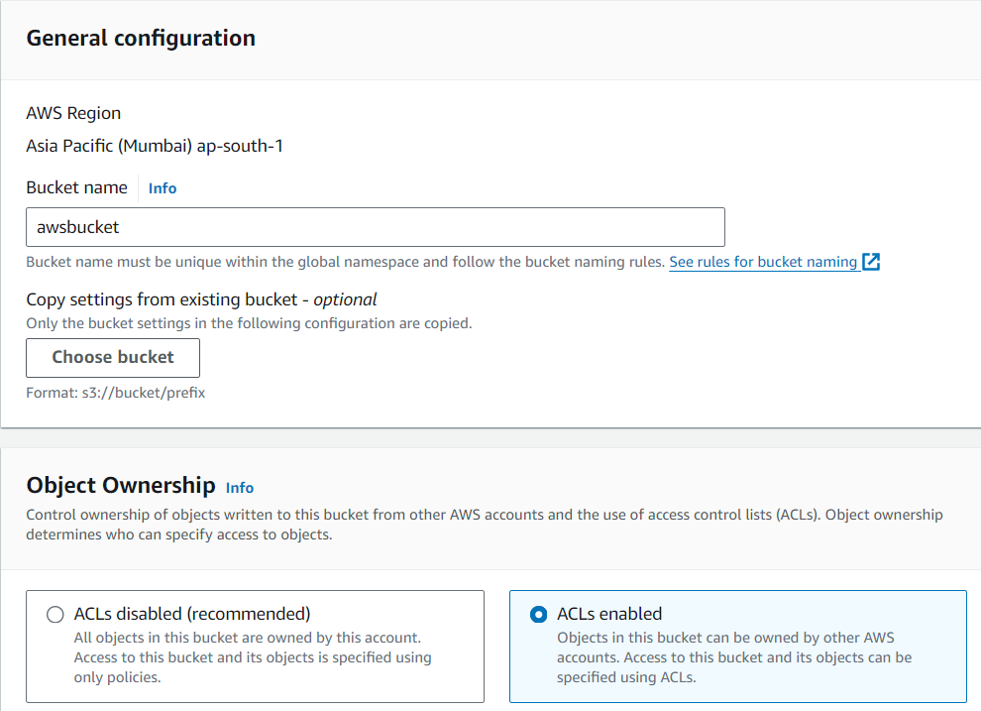

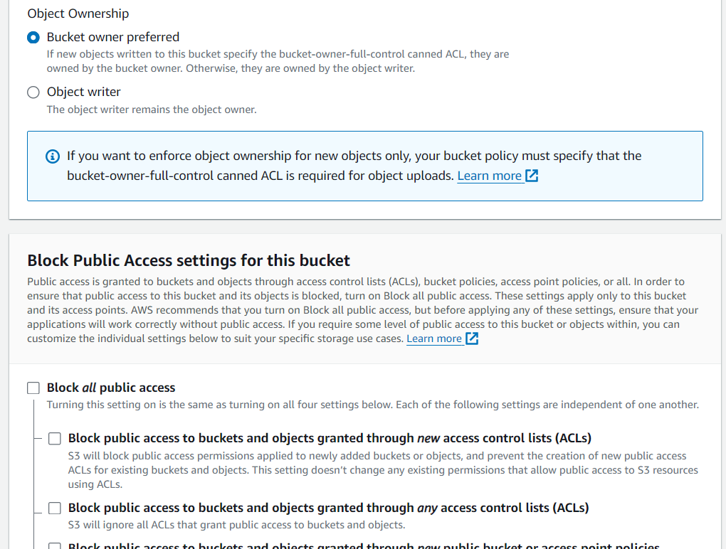

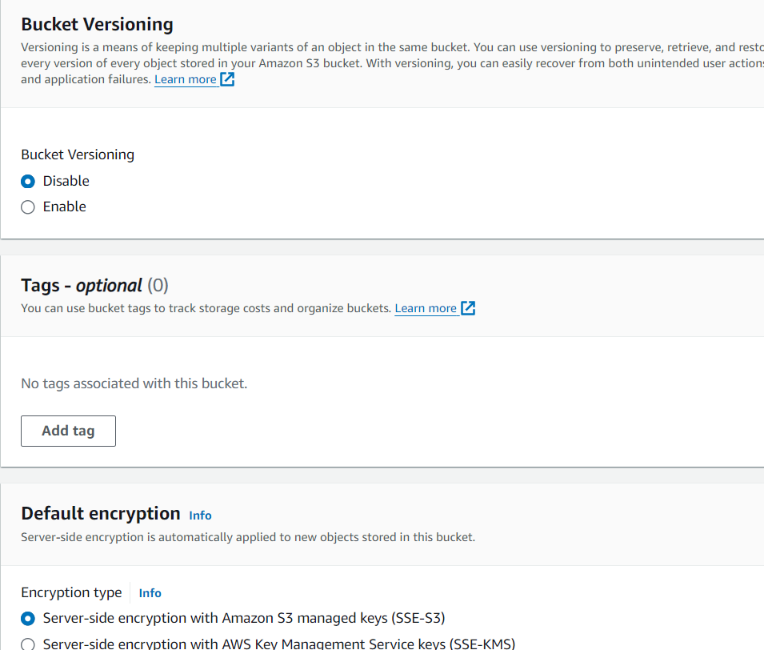

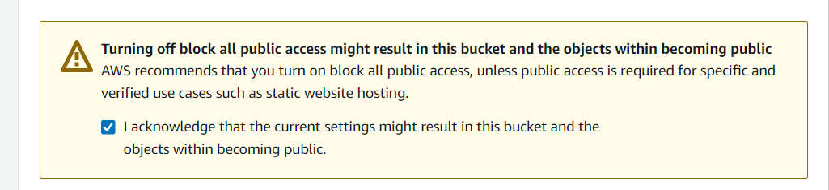

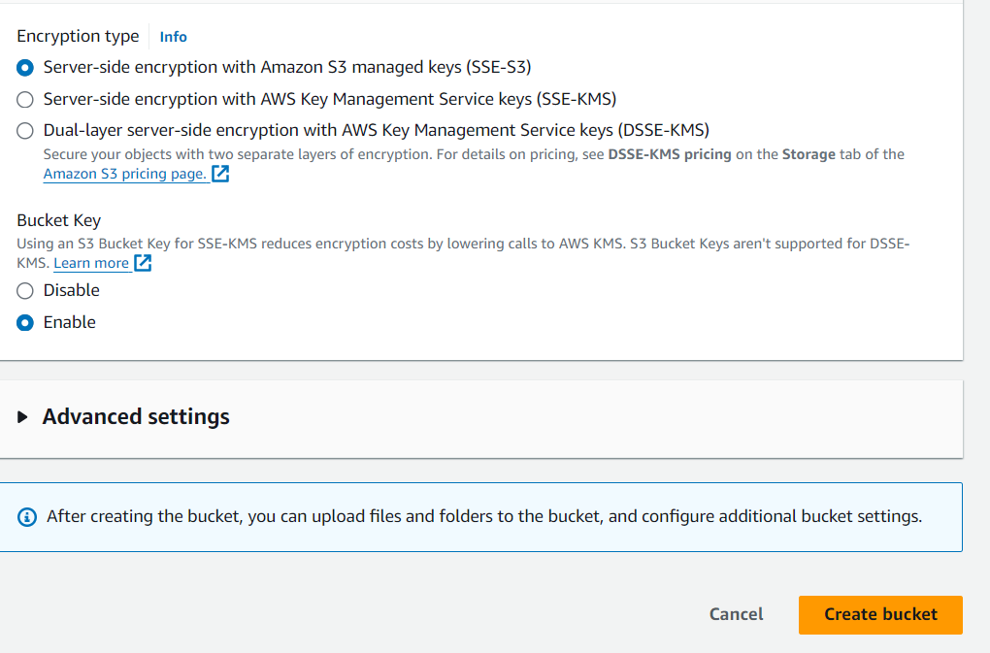

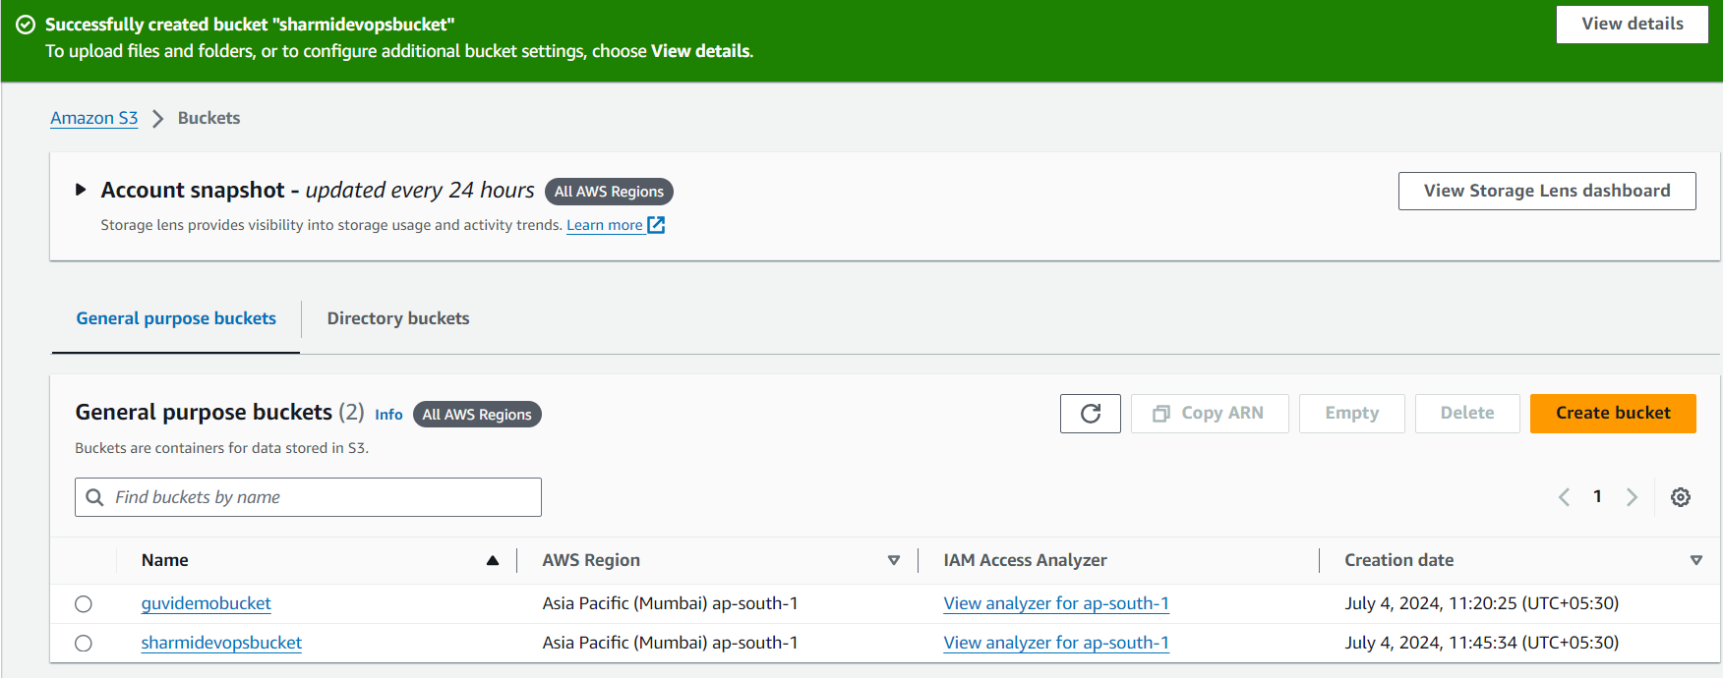

Already we download it in tooplate.com and unzip it .put it in laptop

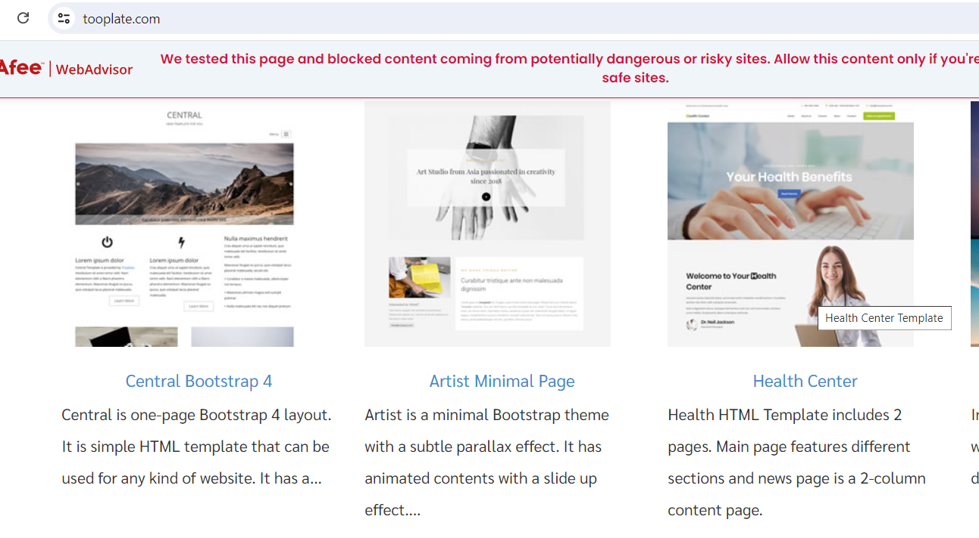

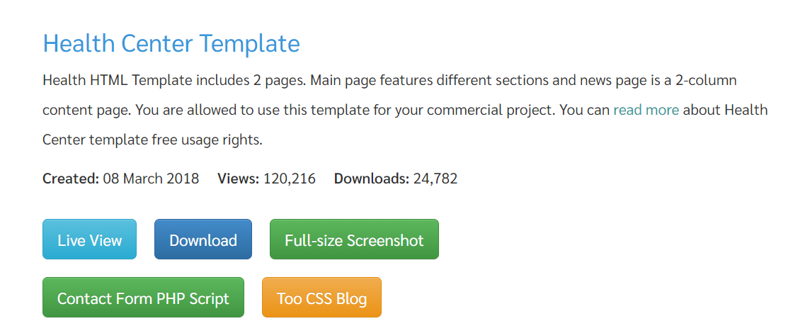

After download in laptop unzip it.then only upload in my bucket.

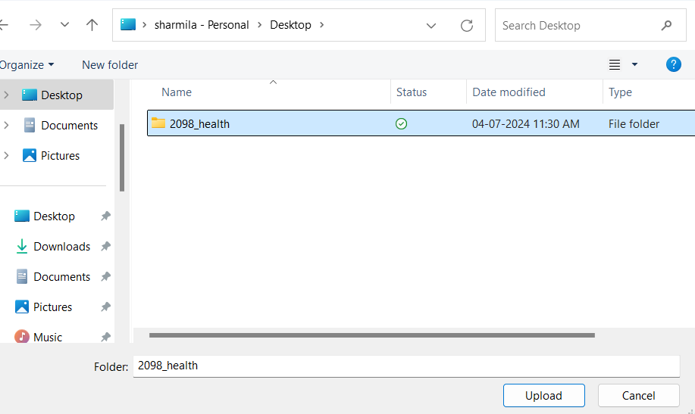

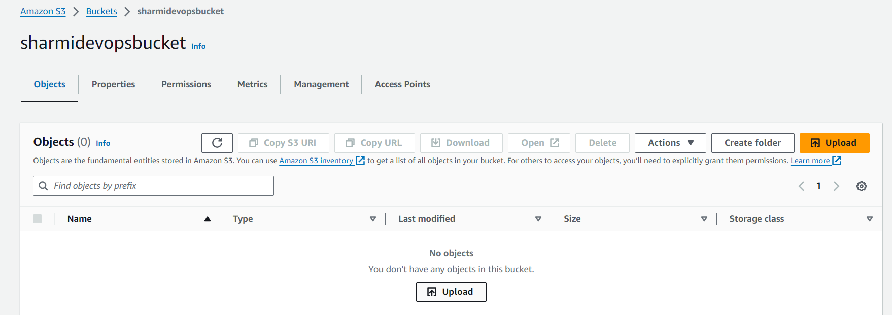

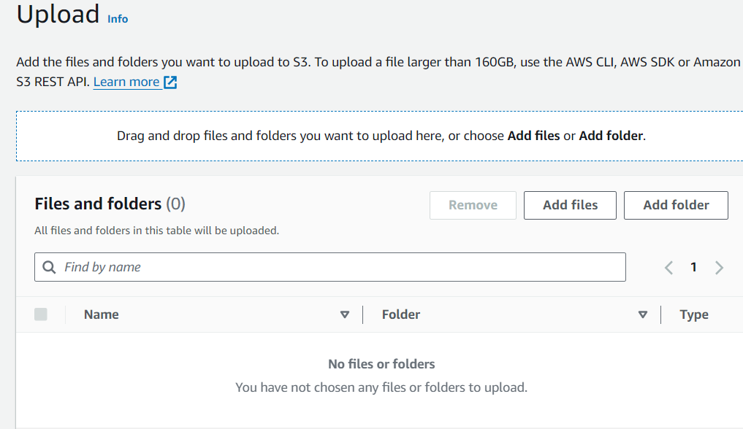

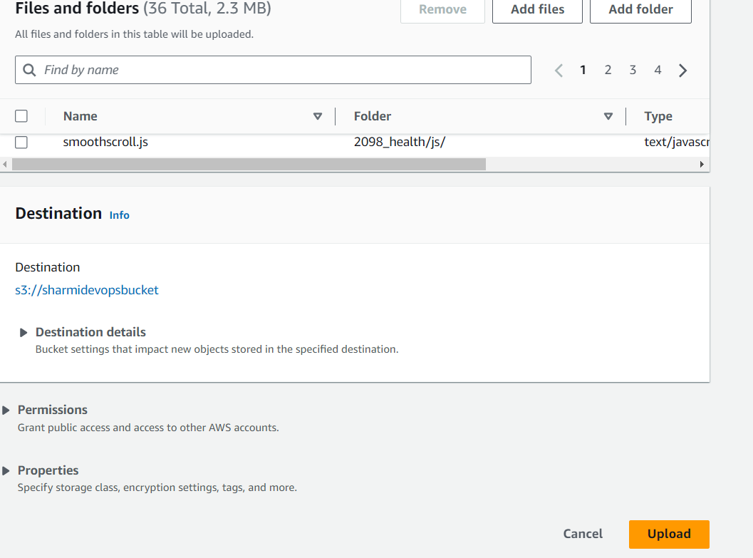

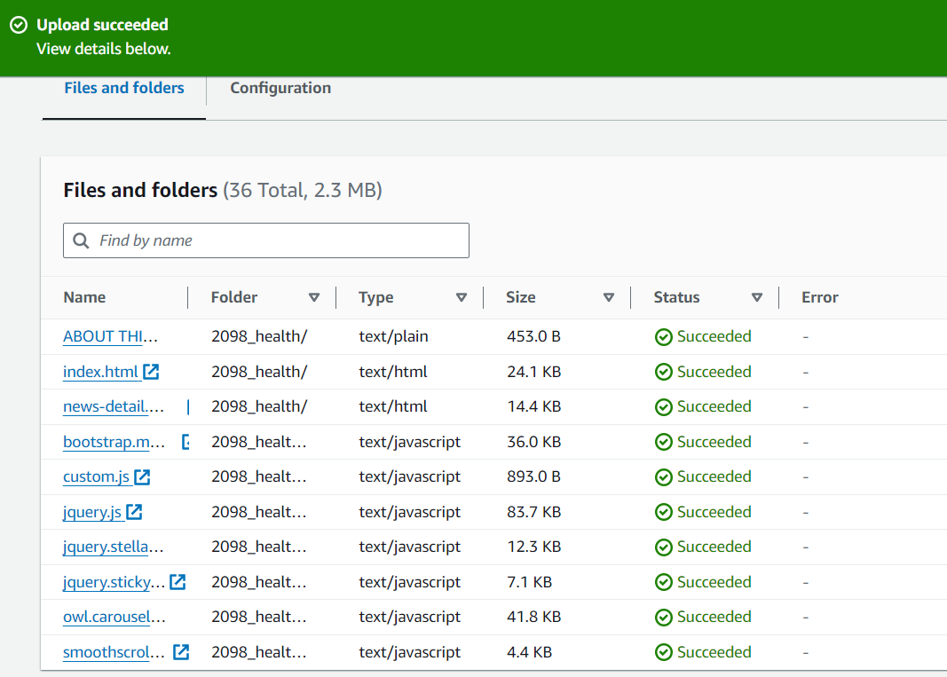

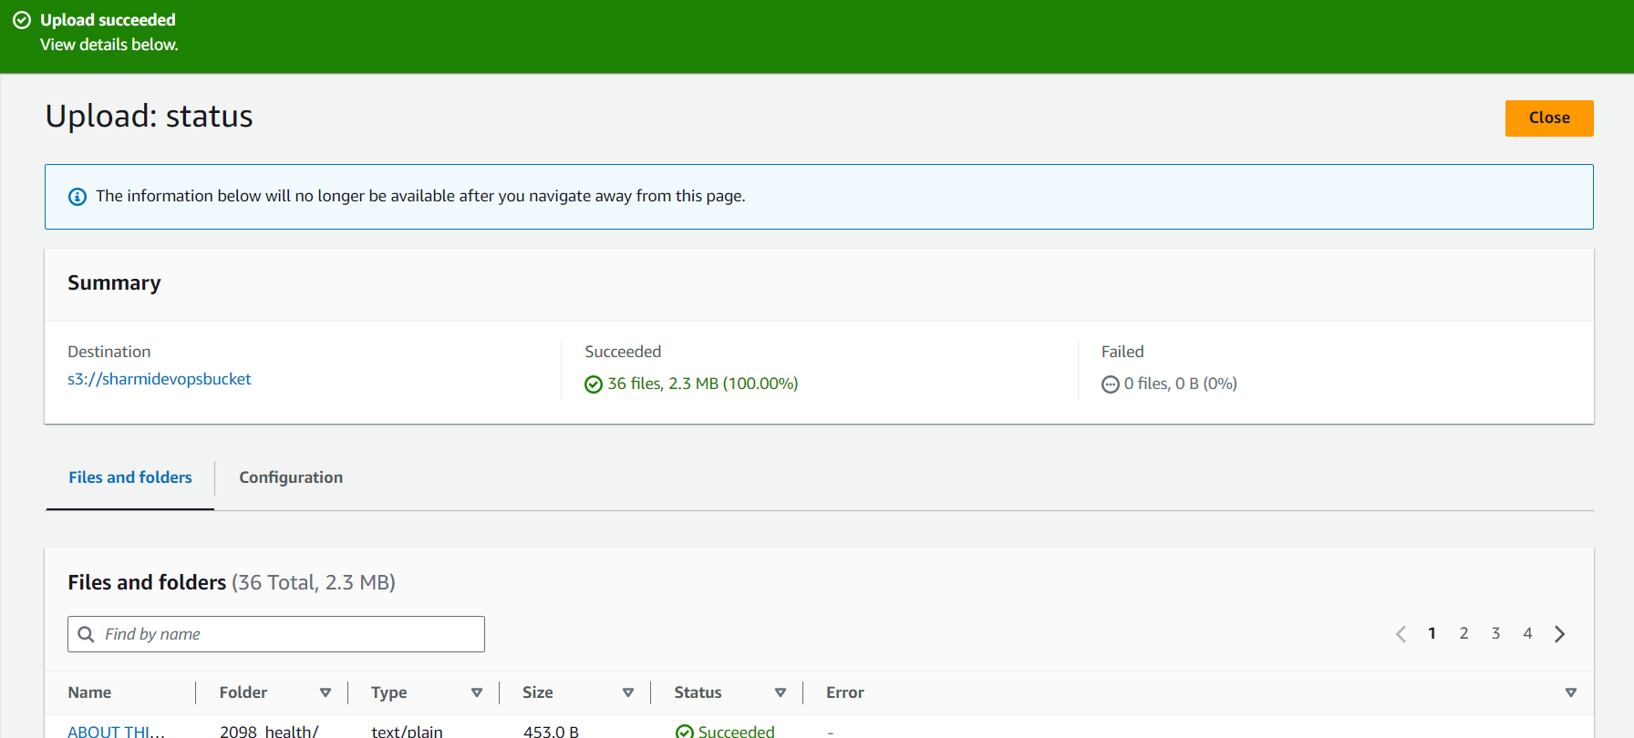

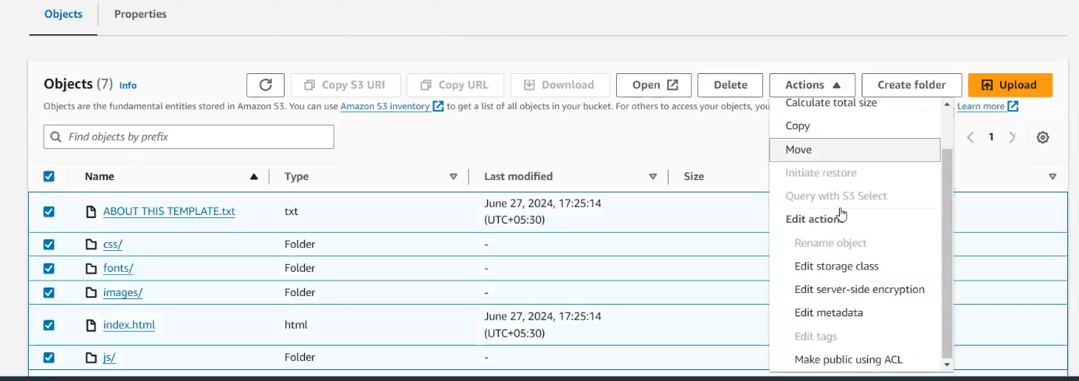

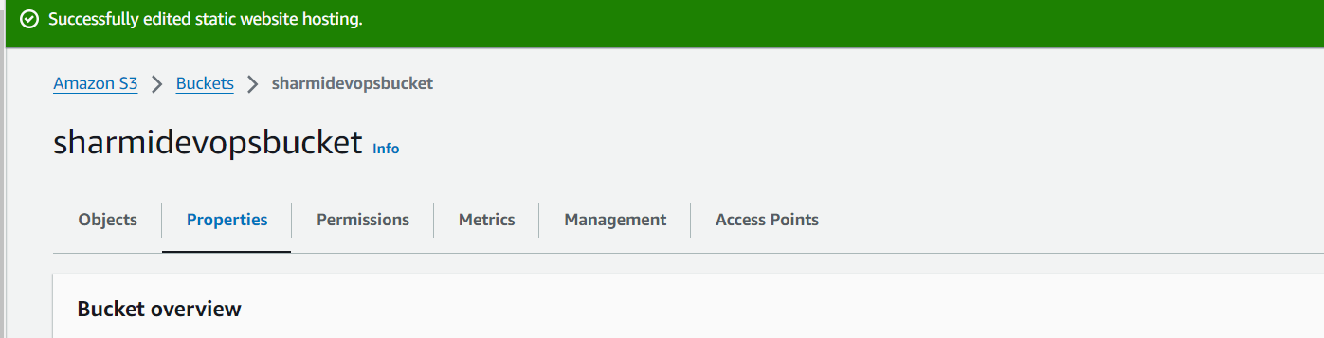

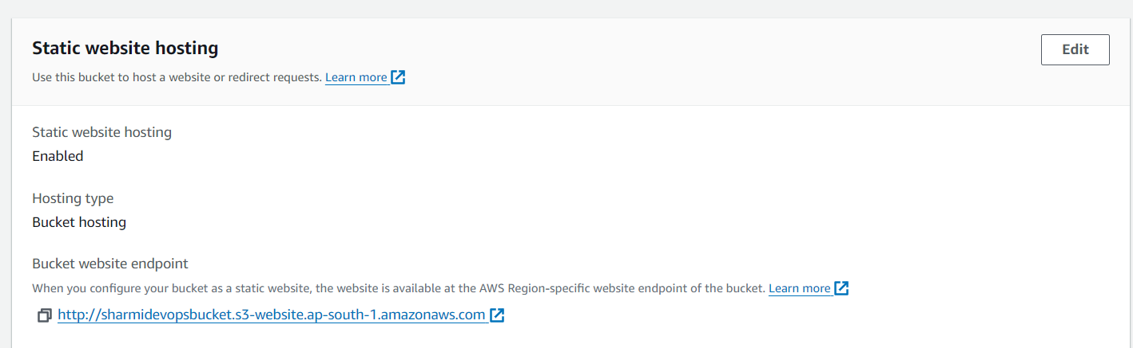



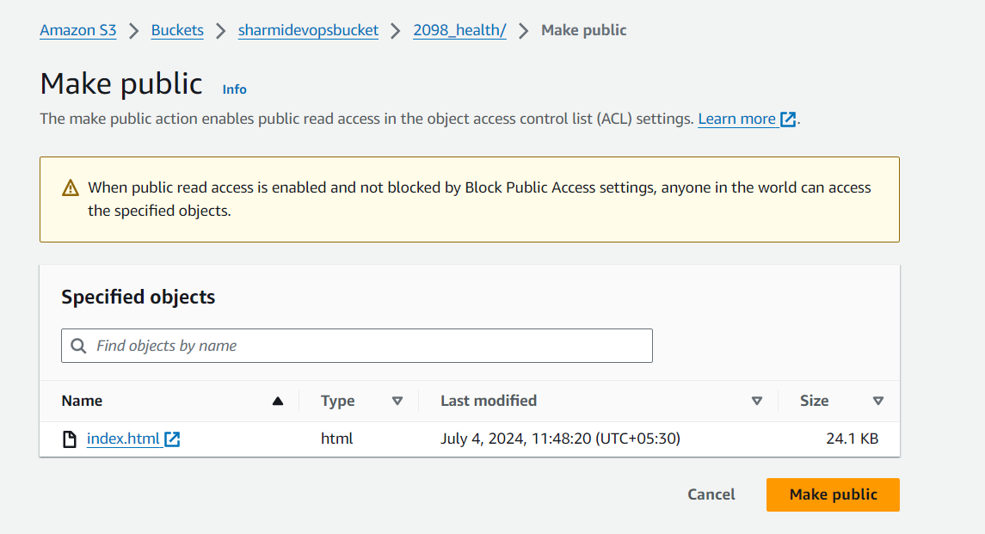

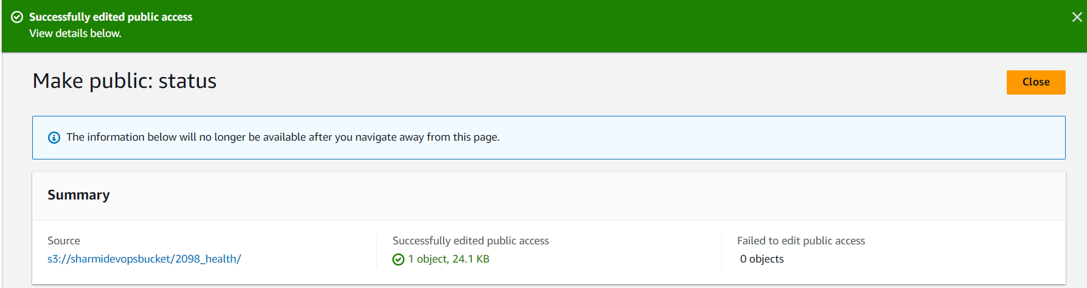

Getinto index.html copy the url paste in browser

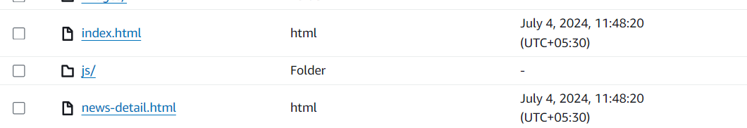

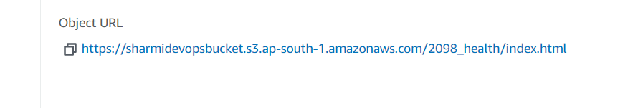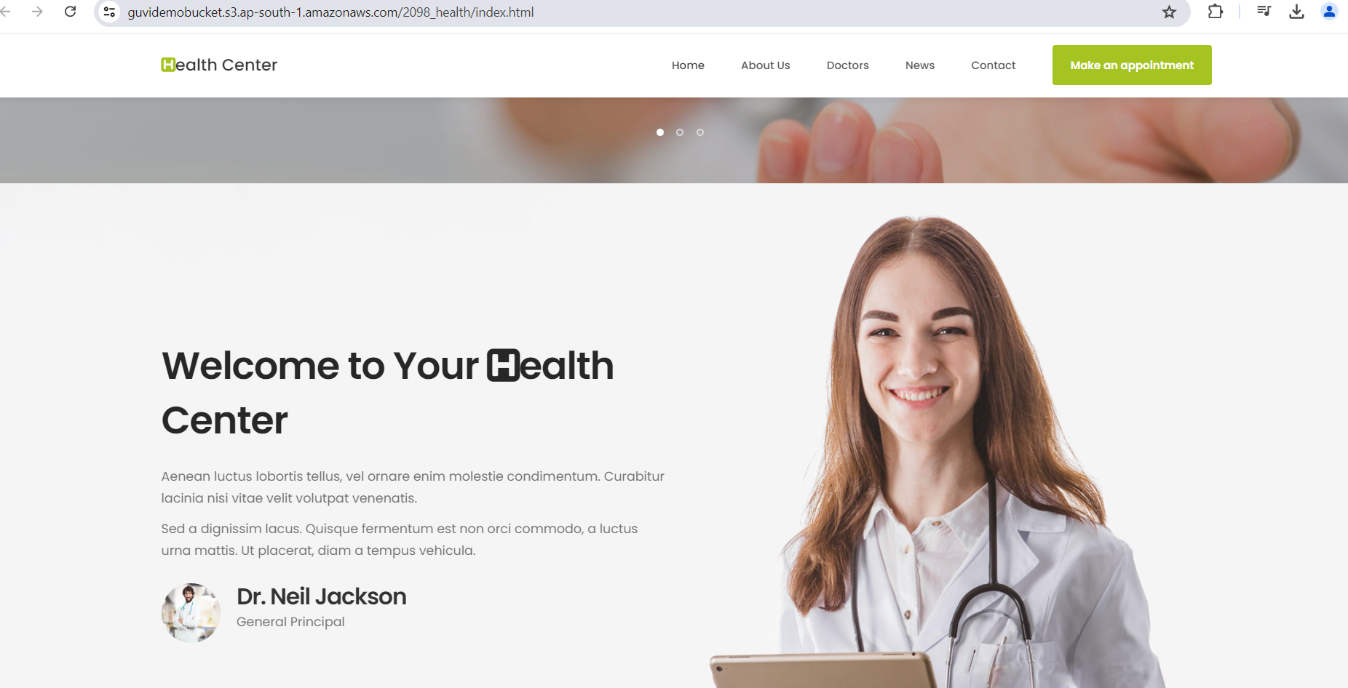

**Elastic block storage (EBS):**

* **if you want to expand it, if you want to increase the storage size of your Ec2. Mission, what we do. We can create elastic block storage and we can mount it to our Ec2 mission only. Not did other services**
* **how you mount your HD. Or SSD. You purchase it separately, and you can mount it to your laptops or your PC. Same thing. We do it here.**
* **if want to increase the storage, or if I want to share my storage, then I can go with elastic block storage.**
* **here all your data are stored in the form of blocks**
* **It is a block-based storage. Here it runs on the Ec2 operating system. It cannot run separately. In order to access your ebs, you have to mount it with your Ec2 mission.**

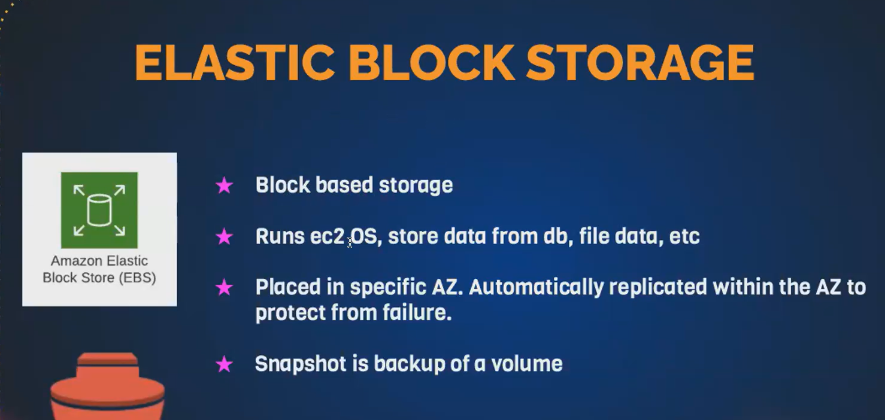

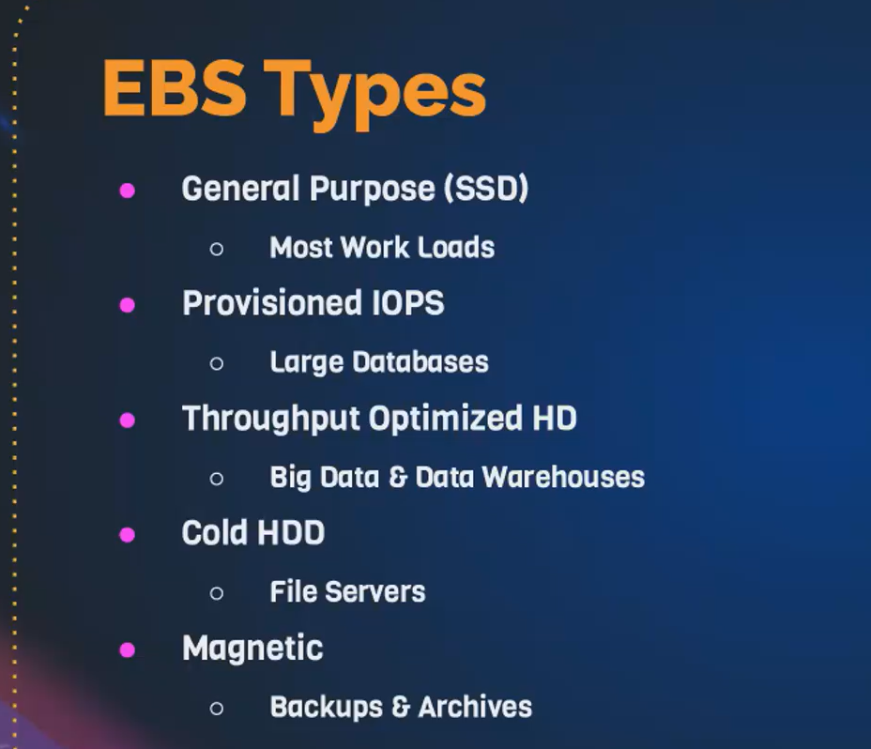

**How to create elastic block storage – volume:**

Goto ec2 🡪left side elastic block storage available🡪click volume

**1st create a volume** ,that volume attached to ec2.

**different types of volume type. You have GP3, GP2.**

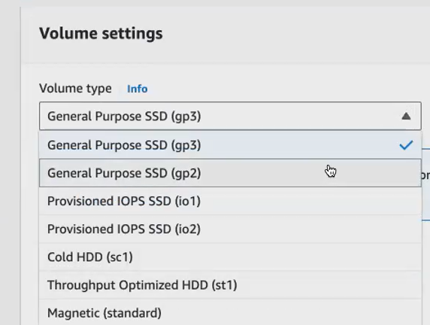

**if you're using a big data application, go for throughput optimize. If you're using a large application where you it should be faster gaming kind of an application. Then you go for pro provisioned iops.**

**You're using a normal web based application go for general purpose**

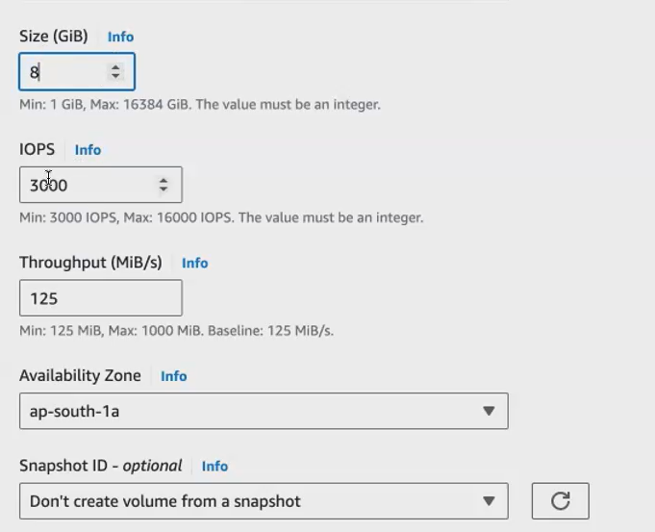

* **Gb 100 Gb. They have given. But for us, since we are at the retail limit we can only use still 30 Gb Of volume.**
* **IOPS 3000 .it means what is the time taken for reading and writing the data inside a volume.**
* **Availability zone as per given**
* **Snapchat not given here. we create it manually. Suppose we want, can create**
* **Click create volume .it can be created**
* **We give name for volume**
* **Suppose we can access that volume, that can be attached to ec2.so create new ec2.**

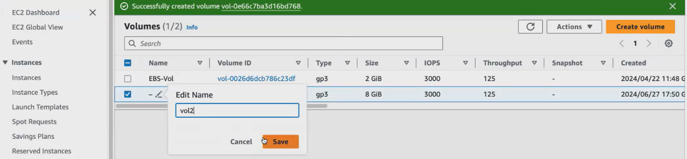

* **During launch ec2 default volume can be created.**
* **here by default the root volume. So every machine comes with the root volume. So you get 8 Gb. Of default value. You can extend it till 30Gb.**
* **this is nothing but your ebs that gets attached by default with your Ec2.**
* **I want to increase my size, so what I can do, I can create a ebs separately, and I can mount it to my Ec2 mission. So here, since we are under free tier, you only can consume till 30 Gb.**

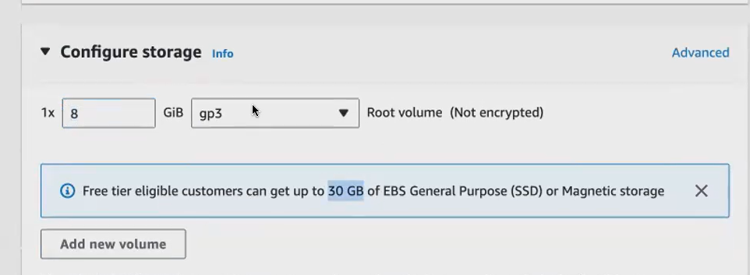

**Ec2 created (demo-ebs)**

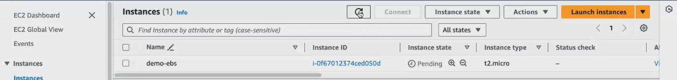**once volume is in available state ,attach volume state option available.**

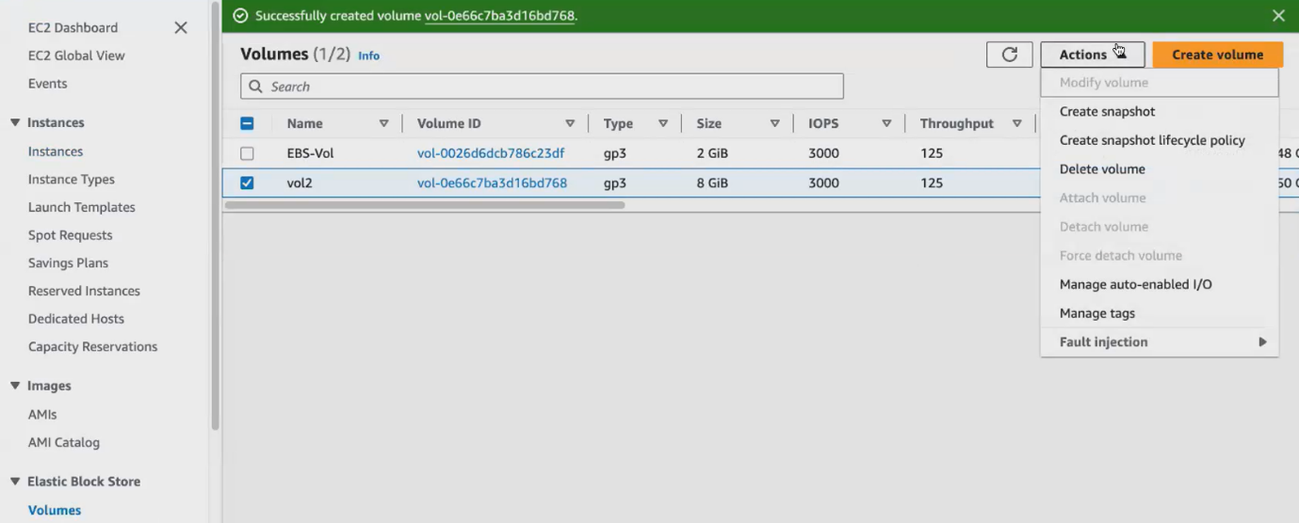

**3rd row is in use volume .that means root volume created ec2 default volume created that volume shows in use.**

**Click attach volume**

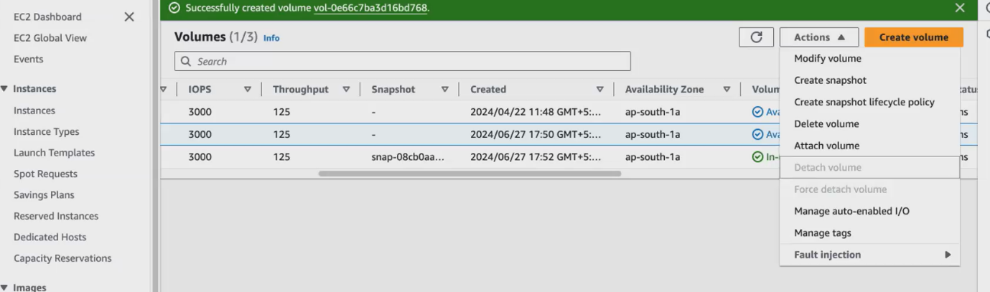

**That instance name shows that means ,in the availability zone that only instance available. Click on it**

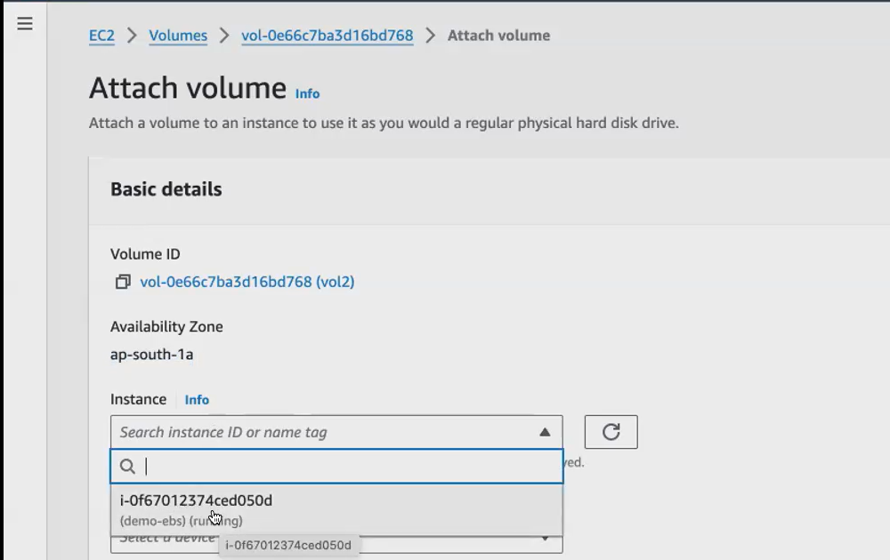

**For linux default we select /dev/sdf. Then click attach volume.**

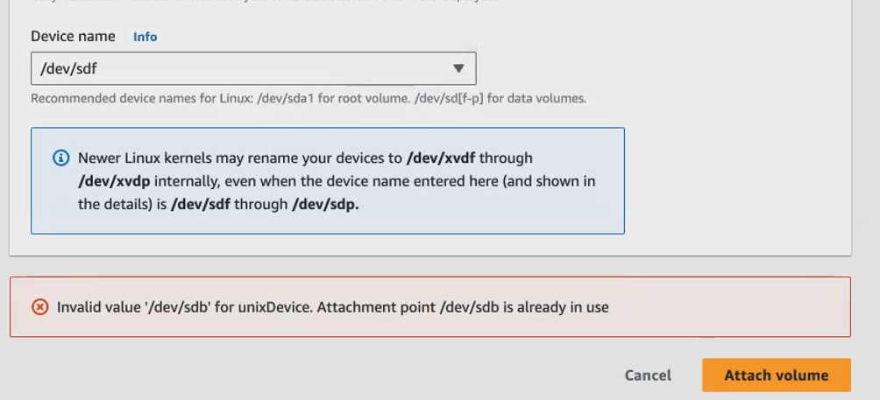

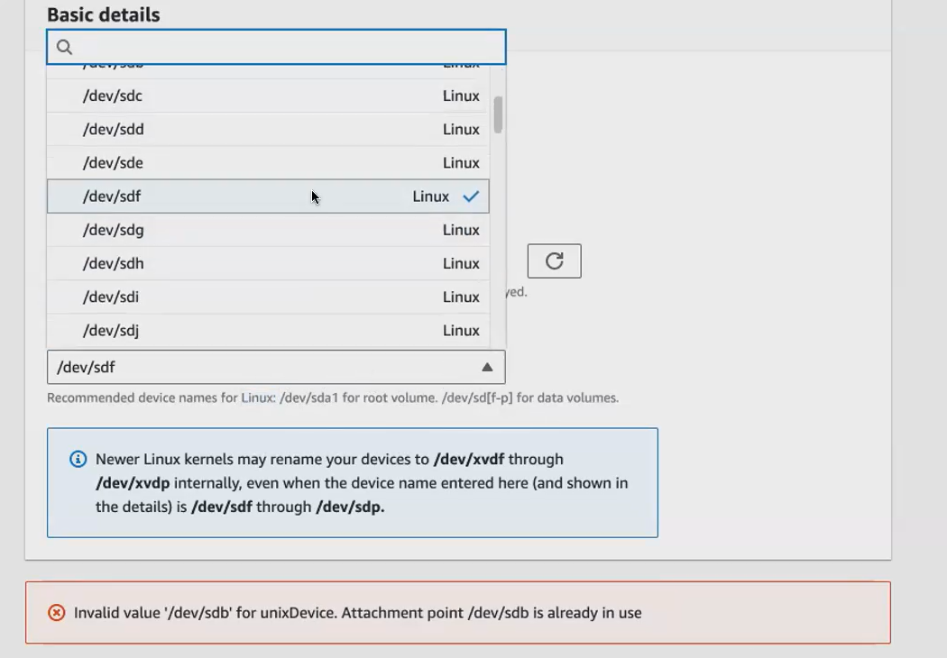

**After attach volume to ec2 ,that volume state changed from available to in-use.(i.e)volume attached to ec2.now we attached that volume only.**

**We can’t access or enable it. some steps can do for enable it.**

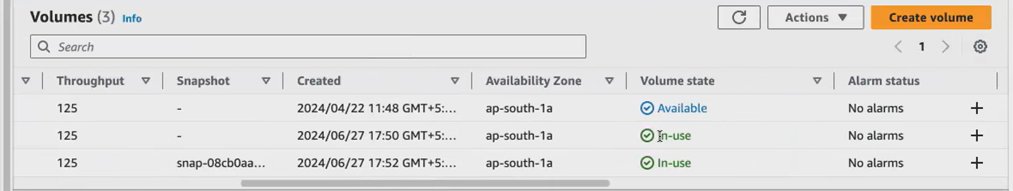

**we use this elastic block storage to persist your data anytime. Your Ec 2 mission, you can terminate it or you can delete it. But if you want to store the data and you want to persist the data, you can go with elastic block storage.**

**Now go to that instance. Connect to ec2.**

**how do you check the disk that has been attached to your Ec2 mission that's running inside your Linux mission. We have a command called Lsdlk**

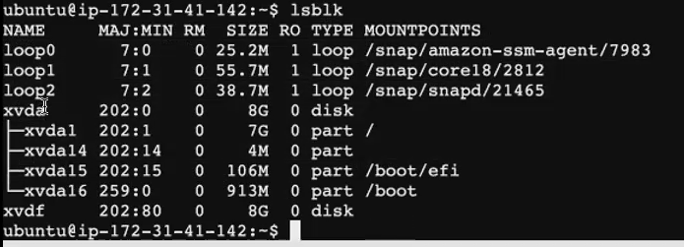

**Xvda -root volume**

**Xvdf – we created that volume. Only disk is there no partition there**

**Partition is not happened, and we are not mounted. Still, we have not given particular path for mountpoints.Only when you mount it the data will be stored. The data from the mount point will be shared with your disk.**

1st you have to format the disk so that it can accept our data.So 1st format that this with a file system (ex2,ex3 (older vision)ext4,ext5). **Currently commonly used is ext. 4, we call it as for 4 extended file system** .so that the data can be stored inside my disk in a particular format.

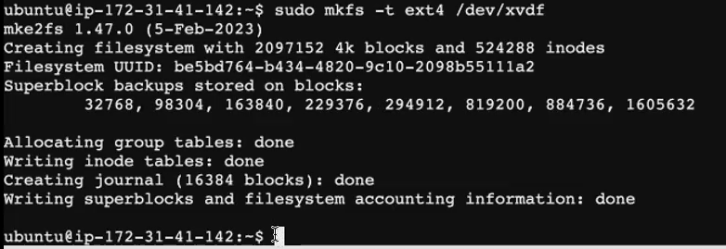

Mkfs – **Means, make file system.**

-t ext4- what type format is used ? extended file system 4 used here

/dev/xvdf – this disk formatted. **Xvdf – we created that volume**

**Now ebs volume is available**

**Then create the mountpoint (path) to ebs volume:**

**/mnt/my_vol path with any folder name that created. We give anything**

**That mountpoint (path) to ebs volume (disk)**



Sudo mount – where I mount that volume

/dev/xvdf – in that disk we mount volume in path /mnt/my_vol

Now disk is mounted to that particular path. But this mount is temporary. If not permanent ,whenever we refresh our machine that get deleted.

How to make this mount as permanent. We make it as permanent then only my data not get deleted. Access at any time. For this we update /edit a configuration.

**Where do you have our all our configuration file in the Linux Machine? All configuration folder inside etc folder?**

* **in the Root Directory, you have lot of system files.**
* **inside your etc folder, you have your configuration files.**
* **inside your bin folder and sbin Folder, you have all your Linux commands. all the binaries (i.e.)the executable binaries will be there inside your bin folder, and as well folder**
* **inside your prop folder you have all your system related information same way inside your, etc folder. You have all your configuration files**



* **Now, I want to change my file systems configuration. So I want to update the file system inside etc folder.**
* How to make this mount as permanent. For this we update /edit a configuration.for this we use nano /vi editor



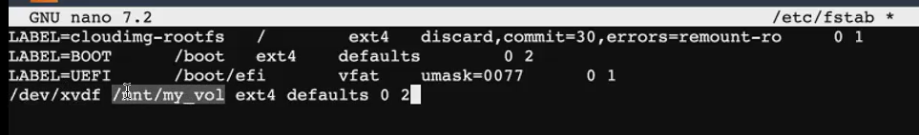

**/dev/xvdf – disk name**

**/mnt/my_vol - mountpoint (path)**

**Ext4 - extended file system 4.specific fs name we give**

**default means - optional flags that you attach. You're giving it for this ebs vol.When you give default, which means I can perform read, write, operation, execute operation, sync operation. all those operations I can perform on this this.**

**0 - means your file system should not be dumped.**

**2/1-** **means while booting up ,when will my volume will check .suppose we have attach 2 ebs vol (root vol, my custom vol)**

**1- means 1st my vol checked then root vol checked.**

2- means  1st root vol checked then my vol checked. Instead of 2 , 1 also give

**Foe check m.p mounted or now. Give cmd lsdlk.now m.p mounted**

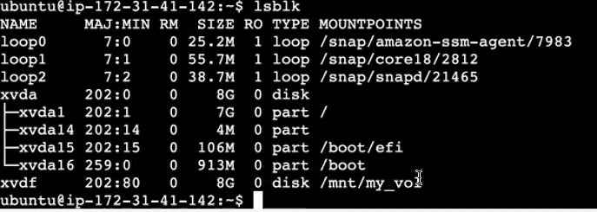



**This command gives complete details of ebs volume**

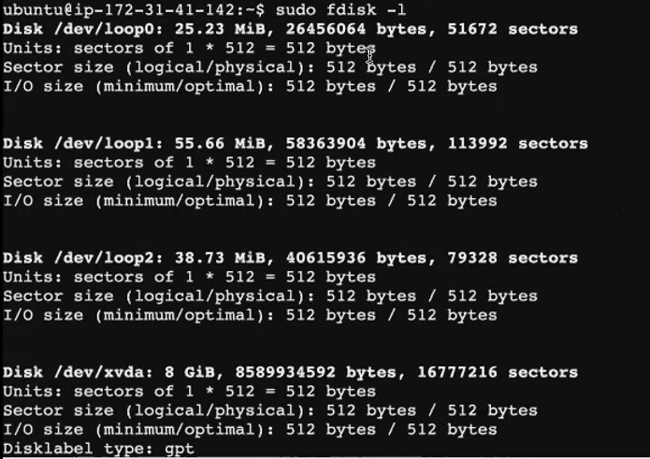

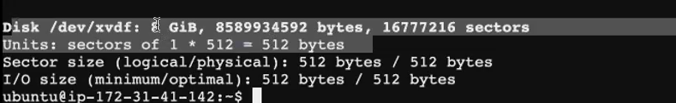

**Yasmine ebs vol documentation**

<https://docs.google.com/document/d/1gTMGBG4tkiQrYAsXsGoE9RbAj5MsSU9Bzj9ahh2B-0E/edit>

**EBS – SNAPCHAT:**

**you want to share this data or use this ebs volume to a different to a diff ec2, which is located in a different availability zone or a region. You can go with snapshot. you can convert your ebs volume into a snapshot**

* **snapshot, is like taking a backup and also sharing your Ebs volume with different region or different availabilities.**

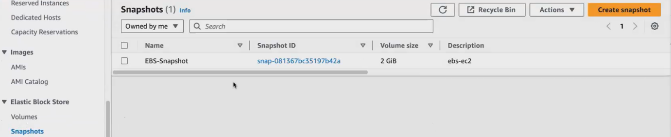**Select name of my vol**

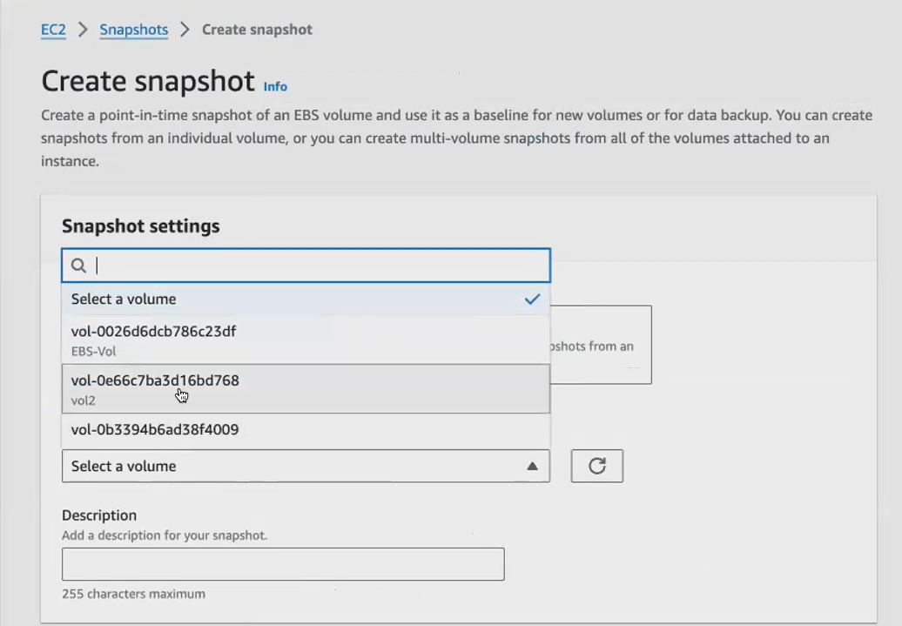

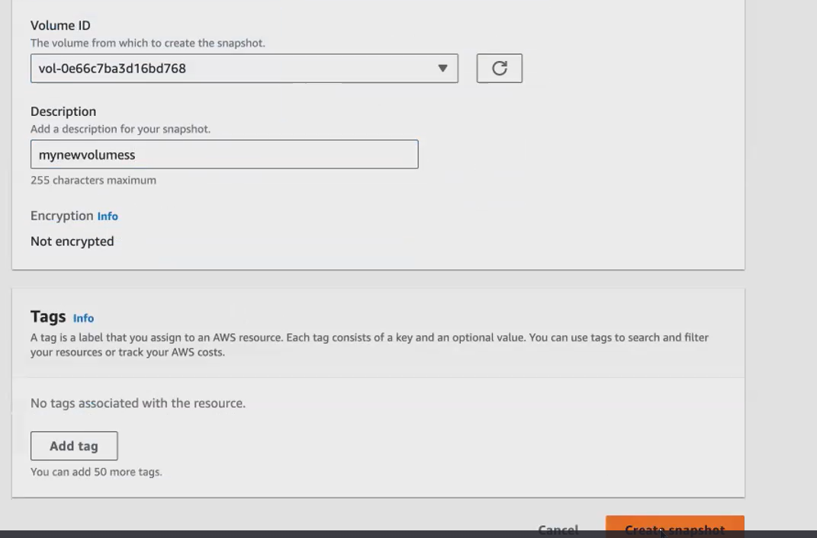

**Give name of my ebs vol snapchat**

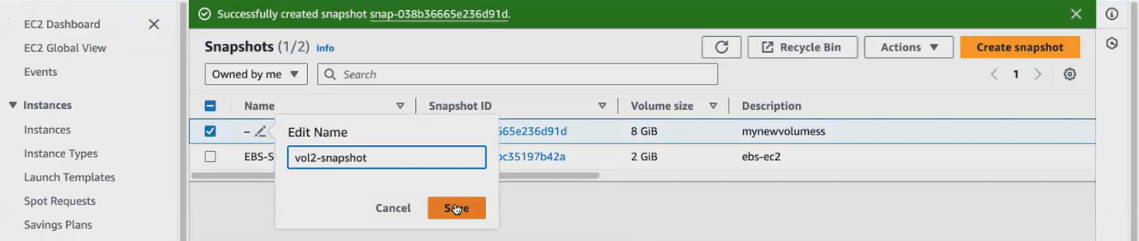

* **snapshot is created for that volume**. **using this snapshot, I can attach my Ebs volume to a different, the Ec.2.**
* **now I have created a snapshot out of my existing volume.**
* **you have taken the snapshot. So, this snapshot will contain all the data that is there in my volume.**
* **Assume that you have stored some data to this volume, and you have taken the snapshot.**
* **Click my snapchat🡪 snapchat id.Let me go and fetch the id of the snapshot that I created**
* **just get into your snapshot click on actions. You have an option called create volume from the snapshot.so, you can create a volume from the same snapshot, but in a different availability zone you have to create.**

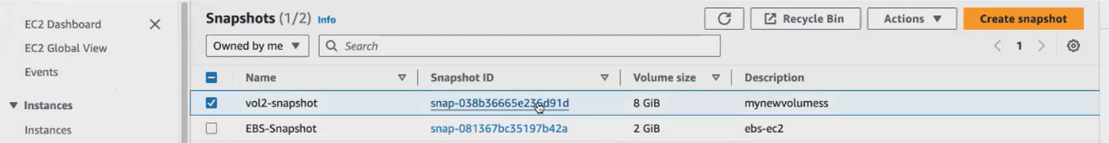

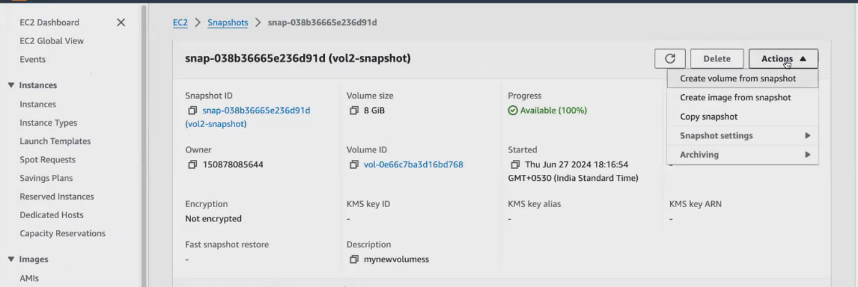



**already we given that region for my volume. Now select diff availability zone**

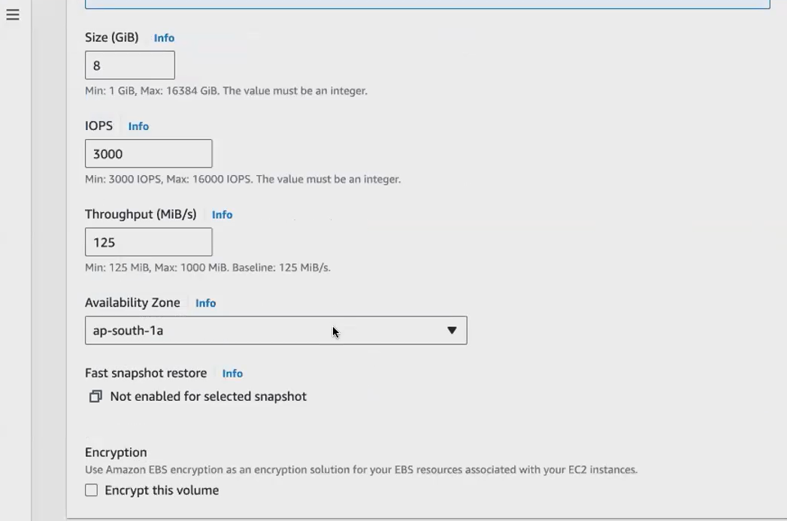

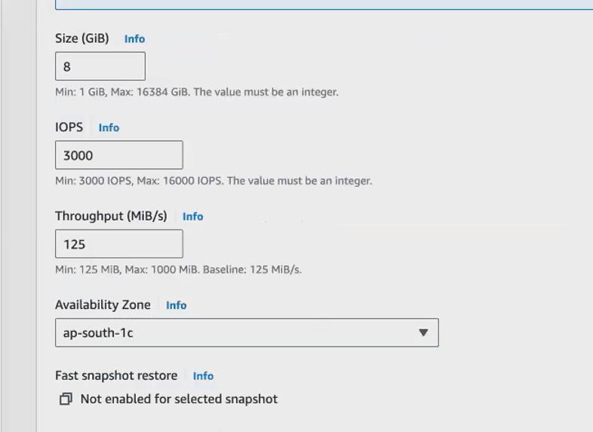

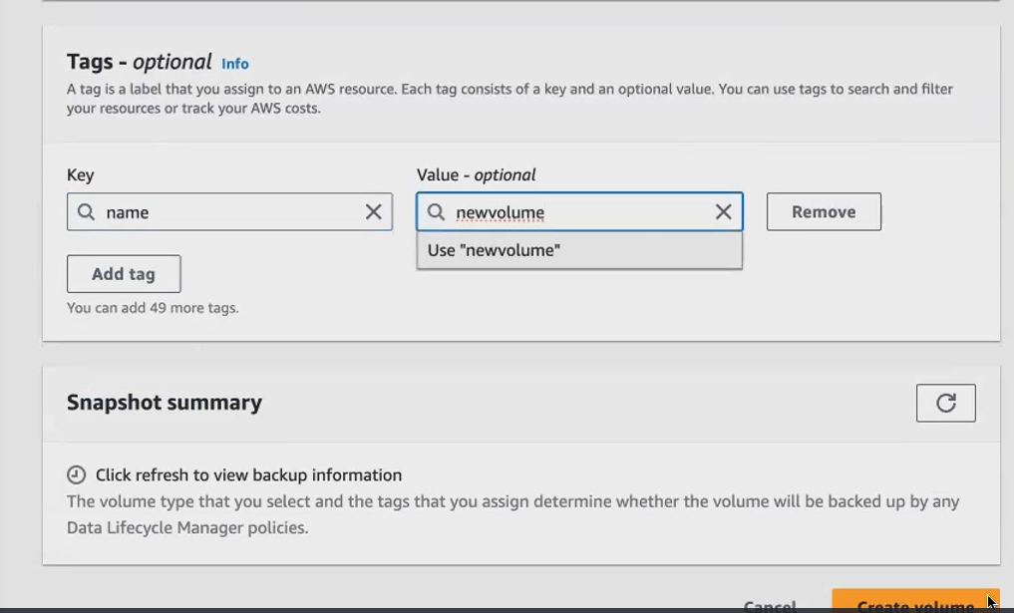

**Now volume created with snapchat with diff region**

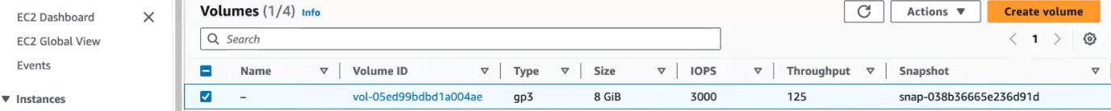

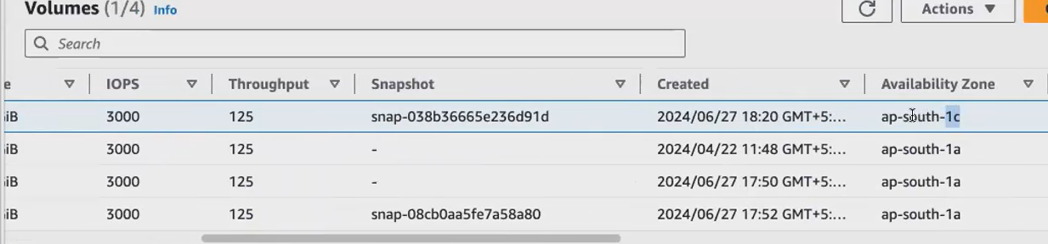

**How to share this v-snapchat with diff region:**

* **EBS is limited to a single availability zone and ec2.we cant share with multiple R and ec2.so we have another option called as EFS.**
* **where you can use EFS, you can share EFS simultaneously. At the same time, you can share the EFS with multiple Ec2. You can share it across multiple EC2 and regions.**

**Finally del all volumes ,because its chargeable.1st detach vol & del.**

